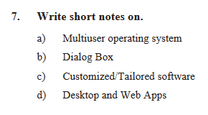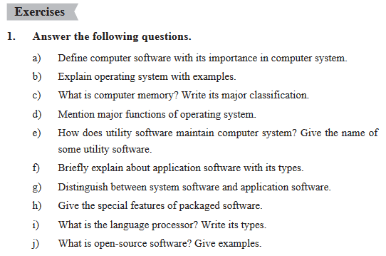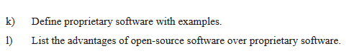

**Write the technical terms of the following**

1. Program which controls and operates computer hardware to perform a task.
2. Co-ordinates, controls and manages computer hardware and resources.
3. The background area of the Windows screen.
4. The small picture buttons that represent files, folders, programs, etc.
5. A gateway to user to see contents of storage device.
6. Contains deleted files and folders.
7. Converts high-level language and assembly language into machine level language and vice versa.
8. Converts the program written in HLL into MLL whole programme at once.
9. Maintains computer software and hardware.
10. Designed to fulfil the requirement of the user.
11. Freely available software and source code.

**Write the technical terms of the following**

1. Program which controls and operates computer hardware to perform a task.
2. Co-ordinates, controls and manages computer hardware and resources.
3. The background area of the Windows screen.
4. The small picture buttons that represent files, folders, programs, etc.
5. A gateway to user to see contents of storage device.
6. Contains deleted files and folders.
7. Converts high-level language and assembly language into machine level language and vice versa.
8. Converts the program written in HLL into MLL whole programme at once.
9. Maintains computer software and hardware.
10. Designed to fulfil the requirement of the user.
11. Freely available software and source code.